|  |  |  |
| --- | --- | --- |
|  | | |
| **Welcome to ‘The Pulse’** | **The Pulse**  “The heart of God  to the heart of the community”  **June 2018 Issue** |

The Pulse is newsletter produced by the Ellesmere Cooperating Parish. We are three congregations that make up a rural parish in the south-eastern part of the Selwyn District of Canterbury, NZ.

Our congregations gather folk from Leeston, Southbridge, Dunsandel and Brookside, drawing people from all walks of life, with a high proportion involved in farming or associated services or retired. Our main worship centres are at St. David’s, Leeston and Trinity, Dunsandel. Our Brookside congregation has shared use of St. Luke's Anglican Church at Brookside.

**Purpose Statement:** ‘*To spread the good news of Jesus by committing ourselves to work and worship together, to love and care for one another, and to be of value to God in our community.*’

We believe that the Bible is the Holy Spirit-inspired Word of God, that Jesus Christ is the Son of God, and that he calls his church to mission locally and globally.

To find out more about the Ellesmere Cooperating Parish, please take the time to visit us on line at [www.churchatellesmere.org.nz](http://www.churchatellesmere.org.nz/)

We hope you enjoy this issue of The Pulse.

Your newsletter was delivered by:

…………………………………………………………….

Phone: …………………………..............................

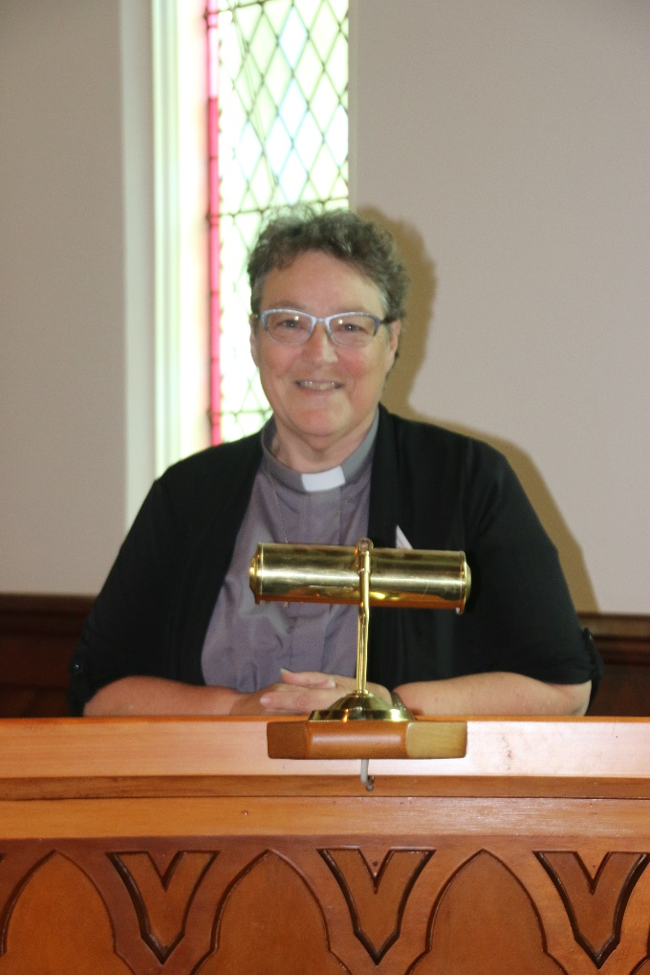**Parish Council Reports from Rev. Heather Kennedy – March - May 2018**

I would like to begin this report with a big thank you for the year I have been in this ministry. I particularly appreciate all the aspects of parish life that are undertaken by the laity; those on rosters, those who provide pastoral care and those who administrate the affairs to the parish. Hopefully the Methodist Stationing Process will provide the parish with a Presbyter who will minister with you for many years to come.

* Thanks also to all who attended the Parish Picnic, for the food and fellowship, especially with members of the Ellesmere Anglican Parish.
* Thanks also to those who helped with the presentation of the World Day of Prayer services at Dunsandel and Leeston. It was a challenging service to present and everyone did very well.
* The Southbridge Home Group meet at Bev Gilbert’s home and share in Holy Communion quarterly. We plan to inform more folk of the details and encourage them to attend.
* In March I officiated at the funerals for Alan Brown, Joyce Hillyer and John Withell.

I recently attended the Central South Island Synod at Dunsandel. Thanks to all who helped to host this day, it was very warm hospitality and was reflected in the business of the meeting. I also attended the UCANZ Joint Regional Forum meetings last week and attending the Standing Committee meeting in Wellington.

Thanks to all those who helped provide ‘Devonshire Teas’ in St. David’s church foyer for the Leeston Fete. Thanks for the scones, muffins, pikelets and many other items, time and talents. It was lovely to enjoy the Celtic Band playing in the church for a while as well.

The Tenebrae / Passover Meal observed at Dunsandel was an event greatly appreciated by those who attended. It was interesting to see that some had done their research on appropriate food to bring for the meal. We even had plenty left over.

The Good Friday service was attended by a good number of people and even though it was cold in the shade, and some people hadn’t brought chairs to sit on, the service went well and all the churches in Leeston participated. Morning tea in St. John’s Church Hall was once again well provided for by a good number of hot cross buns.

The idea of having a Barbeque lunch after church at Dunsandel, in April was well supported. It was attended by most of the local congregation with food and fellowship enjoyed by all. A bit of change from having lunch at ‘The Store’.

In March a small group of St. David’s Fellowship group met at the manse for devotions, sharing ‘show and tell’ items and stories, followed by afternoon tea. The manse is available for meetings and gatherings whenever needed.

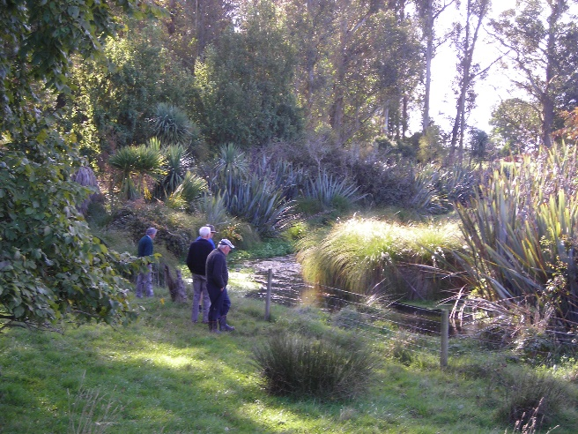Thanks for all who helped with the hosting of the small group of international guests prior to the International Rural Ministry conference at Lincoln in mid-April, with accommodation, meals and transport. It was a real privilege to have Rev. Eric Skillings from Canada and Rev. Francois Pihaatea from Fiji preaching at our services. Some of us also attended the ‘Global Village’ evenings during the conference at the university.

IRCA visit to Hart’s Creek

* I visited Ron Cawood twice while he was in Christchurch Hospital and he is now recovering from surgery, at home.
* It is encouraging to see the marble font re-instated at St. David’s, hopefully we will see it put to good use, in the future.
* I recently attended a training day with John and Barbara Titlow at the Church on the Hill, Little River, on ‘Local Houses of Prayer’, a concept developed by Roy Godwin at Ffald-y-Brenin in Wales. It was a very interesting and reflective day.

I was honoured to lead the Anzac Day service at the Leeston Rugby Football Stadium, by sharing a reflection on the significance of the remembrance service, the reading of Luke 6:27-36, offering a prayer and closing the service with the reading of ‘Honour the Dead’ written by Shirley Murray.

I attended the Alpine Presbytery Gathering in Christchurch from Friday 27th to Saturday 28th April along with Noel Dalley. The role of Presbytery Moderator was passed from Rev. David Coster to Rev. Anne Stewart, with David providing an excellent valedictory address. We learned more about the proposed plans for developing the church buildings in Hanmer Springs into accommodation, café, meeting and cinema spaces for community use.

Resource sessions included Rev. Sarah Rice ‘How does the Church participate in Redemptive Work?’, Rev. Sharaine Steenburg ‘Getting the Church back into the Community’, Rev. Hugh Perry’s valedictory speech, Rev. Blair Stirling ‘Ethics, boundaries and motives behind Social Enterprise͟’, Mr Stephen Moe (a lawyer) on ‘Social Enterprises in NZ’. There was also information shared on the ‘Preston’s Project’, the Video Project and Workshops. I attended Darryl Tempero’s workshop on ‘Why did people leave church, and what kind of church would they want to belong to?’ which were thoughts from his Doctoral Thesis.

Following the Gathering I attended Rev. Hugh Perry’s final service at St. Alban’s Union Church as we have known each other for many years – since my father and Hugh were in photography businesses in Feilding and Wanganui.

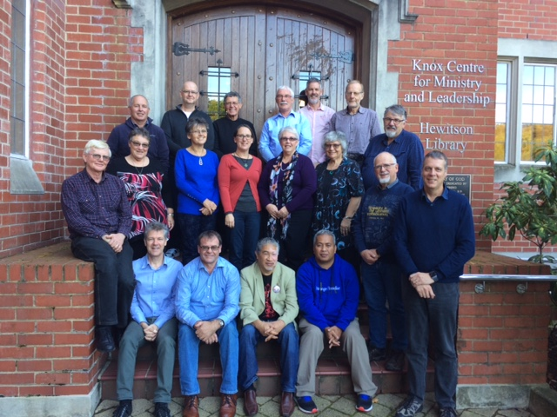As a National Board Trustee, I also attended the ICHC two-day meeting in Wellington, held at the former Home of Compassion, now a retreat centre. Much business was covered and plans for ways ahead in a challenging Health sector.

I have just returned from attending the PCANZ Local Ordained Minister’s Conference This was three days of gathering resources for ministry from the faculty at Knox Centre for Ministry and Leadership in Dunedin. It was also a good time to re-connect with Local Ordained Ministers from all over NZ.

Each morning we ‘Sat with Scripture’ observing the Death and Resurrection of the Lord’s Prayer, with session through the day presented on ‘Loving our neighbours and communities in God’s Mission’, ‘Reframing and Rethinking current forms of church’, ‘Living together as communities of God’s people’, ‘Leading Effectively’ and as part of a current church research project ‘Ministers and Life-Long Learning’. One of the interesting group times we had was looking at ‘Four Modes of Mission Engagement’ where we looked areas where we **worked for** the community, where we **worked with** the community, where we were **being for** the community and where we were **being with** the community.

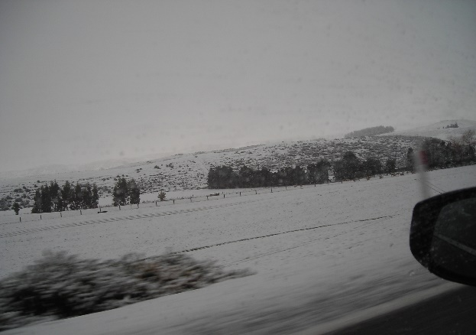Jim and I spent some days in Queenstown after that, with a few days visiting Milford Sound for Jim to farewell his former workplace and colleagues. We then had a few days in Invercargill catching up with our son Dave and our daughter Erin and her partner James, meeting his Mum and Step-Dad for the first time. We also spent time with friends catching up on events and happenings in Invercargill and specifically at First Church. Driving home through snow and falling snow between Mataura and Clinton.

I was saddened to learn of Shirley Barron’s death, and appreciate the lovely afternoon visit we had with her and Peter in April. Her sunny presence at Trinity will be missed by all. Her funeral was attended by a large number who remembered Shirley and all her wonderful attributes.

Thanks to those who worked on the Parish Strategic Plan, you produced a very good document. Thanks also to Teena, Waldo, Don and John for providing worship services in my absence.

Noel Dalley and I attended Methodist Synod in Ashburton and came away with full bellies and slime or silly putty to play with. This related to Kathryn’s devotion for the day.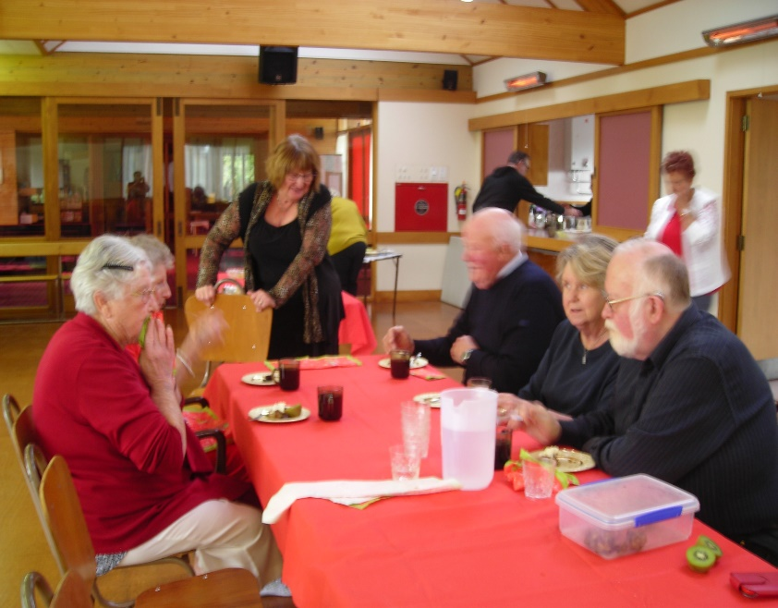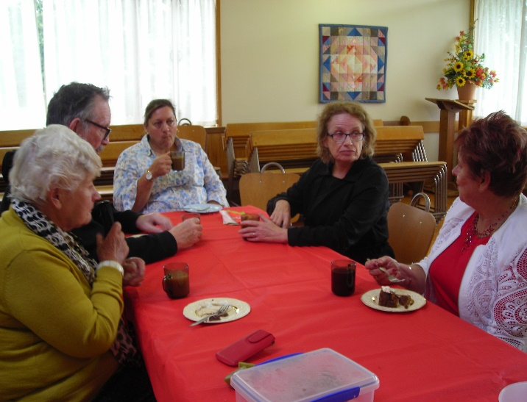

Barbeque Lunch at Dunsandel

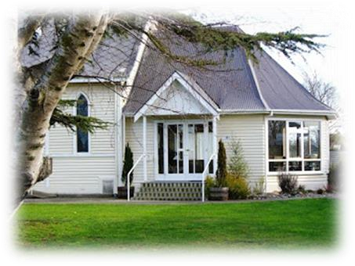***News from the Leeston Sector Group***

***-from Hilary Boal***

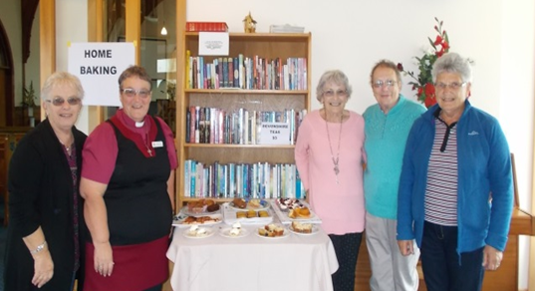We have had a happy and busy three months. Leeston Fete was very successful with us serving about 100 Devonshire Teas. The Weather was very cold and damp and people were pleased to get indoors and have a warm cuppa, while listening to the Celtic Band

playing in the Church.  *Helpers at the “Leeston Fete”*

The February Parish Picnic Service at Killinchy Hall was well attended again and was great to have the Anglican Parish join us. The Fellowship over shared lunch and BBQ and an interesting mix-and-mingle competition, got us up and talking to others.

New tenants moved into the Selwyn Street, Church House in February - a couple with three young children.

Thank you to Kathy Steele for giving our Hall toilets a much needed coat of paint, also a big thanks to you and Anne for managing the ‘Mission Shed” and now with some help from a few volunteers. This is very worth while to the Mission and to our locals who contribute and buy clothes.

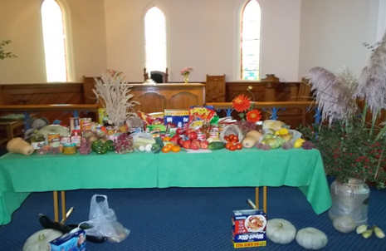A Combined Easter Good Friday Service in ‘Anderson’s Square’ was followed by a Cuppa and Easter Buns in the Anglican Parish Hall, another lovely Fellowship together.

Harvest Thanksgiving…a wonderful table of produce, delivered to the Wainoni Parish and East Christchurch parishes.

Thank you to All who billeted folk for the International Rural Churches Association Conference at Lincoln and for those who participated in the arranged tours around the Ellesmere District.

St. David’s marble font has been repaired and re-instated in the front of the Church. Rev. Heather blessed it, in the Sunday Service just after it had arrived.

The big trees at the front have been trimmed, the lawns well maintained, Church and buildings always kept clean and tidy, thank you, and to all who help with Morning Teas, Door Stewards, musicians, Bible Readers and to the devoted Sunday School Teachers and to the children who come along. Also to the Pizza nights and their helpers.

We give Thanks for the lives of loved ones that have passed away this Year and send our love and deepest sympathy to their families.

To all our sick folk, we wish you a speedy recovery and good health again very soon.

Thank you - Rev. John Titlow, Rev. Don and Rev. Dr. Waldo, for leading our services in Rev. Heather’s absence; all very much appreciated.

To Rev. Heather, thank you for your leadership as we progress through the process of being matched with a new Presbyter.

My God Bless Our Whole Parish.

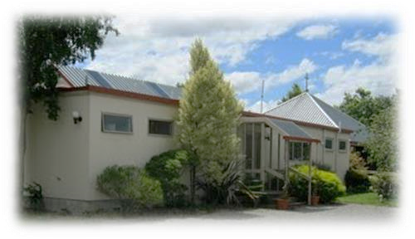***News from Dunsandel Sector group***

* ***From Mavis Barnett***

*Now that our warm and beautiful Autumn is nearly over it’s time to look back at the good occasions our Church has enjoyed this last three months.*

*The World Day of Prayer service organised by the Women’s Fellowship seems to herald the start of the year’s ‘Serious Bits’. This year the 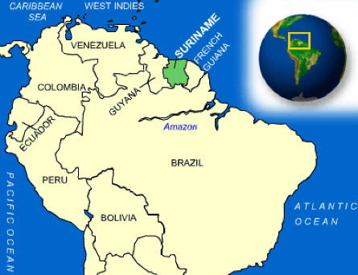women of Suriname had written the service so we tried*  *to use some of the language and sang the songs, of the place at the top of South America of which we were fairly ignorant. But it’s never too late to learn and we did!*

*Methodist Synods from North and South Canterbury gathered together at Trinity for their first meeting in 2018 and we were very happy to host them for Morning Tea and a shared lunch.*

*On March 18th, Rev’d. Lynne led our Harvest Festival Service and the usual colourful display flowers and food a ‘Feast for the Eyes’. WesleyCare and the City Mission were the recipients of the food.*

*Our Easter included the Maundy Thursday Evening Tenebrae Service with a present-day Passover Meal using all the elements in various form. Thank you to all who came and contributed the imaginative dishes which made up a delicious 2018 Passover. Our thanks especially to Rev. Heather and Jim for the thought and work you put in this special time.*

*Robby led our March Café Church using a list of Quotes form well-known people, which produced much food for thought, comments and a great deal of laughter. His choice of nostalgic and ‘old-song’ favourites were a hit.*

*In early April we followed our morning service with a BBQ meal. Eighteen people enjoyed will-cooked sausages and chicken nibbles – thanks fellas! With salads and breads, cakes, whipped cream and coffee – thanks girls! All went down very well.*

*We doubled our congregation numbers when overseas visitors and the local hosts came and took part in our Anglican service. They were here to attend the International Rural Churches Association Conference at Lincoln University and we were delights to meet and greet them.*

*The singing was hearty and joyful, and the Dunsandel Store did great business at lunch-time. Bring on more conferences!*

*Café Church led by Rev. Heather had the fitting subject ‘What does Easter mean to New Zealander?’ Once again, opinions and participation came in good measure. How good it would be to see an attitude change in 2019!*

*On Anzac Day, when a very good turn-out of Dunsandel citizens met at the War Memorial service, tow of our fellowship ladies laid the traditional wreath on behalf of Trinity and the Fellowship group.*

*The Parish Combined Service on the 5th Sunday of April, gave us all a buzz from the loud chatter over morning tea through to a thoughtful service and more great singing. Once again our sincere thanks go to the Clearwater Duo for your input.*

*Mother’s Day was a delightful service in the hands of Rev. Kathryn Walters, the Methodist Synod Superintendent, using the theme of family in all its various forms. We sang and enjoyed new words to familiar hymn tunes which always brings forth enthusiastic harmonised singing.*

*Altogether, it’s been a busy time in ‘little old Dunsandel’.*

**News from St. David’s Friendship Group.**

Our March Meeting was Combined with the Afternoon Fellowship Group, when we met in St. David’s Foyer, the speaker was Karen Ede, who is involved with Youth with a Mission. She is based at the Baptist Church complex in Oxford, where she helps teach groups of Students about the Mission Work with under privileged children living in poor Countries, Karen has been to Uganda several times, where she has helped with the Building of a School and teaching children etc. She had a display of lovely jewellery, cards and other items for Sale all made of paper by the Ugandan Women. The Colourful Necklaces were a favourite with Our Members.

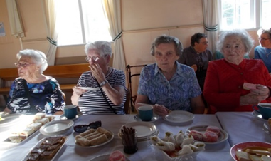In April we met in the Hall to welcome our Visitors from Ilam Life Care. It was a lovely sunny Autumn afternoon for their outing in the Country. Hilary had organized an entertainment afternoon programme with Line Dancing, with the Caregivers and one or two guests joining in, a piano selection of old time tunes, a lighthearted recitation about old age. and its new found friends and a sing-along. A delicous Country Afternoon Tea was enjoyed by All present.

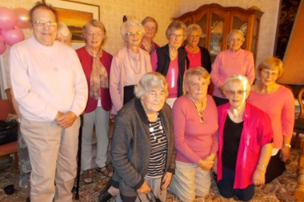Our May get-together was our Pink Ribbon Appeal Afternoon held at Jill and Peter Lemon’s home with 16 present, including Afternoon Fellowship Members and friends with All wearing something Pink. Jill and Hilary had organised a fun afternoon with Competitions to test our memories and our knowledge.everyone donated $10. And with a Lucky Dip, Raffles, and guess the number of sweets in a Jar. $375. was raised for this worthy cause. Afternoon Tea followed the Pink theme, with many Pink goodies to enjoy with a Cuppa. Hilary Boal.

**St. David’s Children’s Programme**

This term our team are focussing on teaching some of the Parables of Jesus. The children are enjoying the messages and the art and craft work they do portraying the story each week. We now have a team of four leaders taking turns to lead, very ably assisted by Sarah Dickson who is a great help with the younger children. The children range in age from 1 year to about 12 years and numbers vary from week to week. With Wi-Fi now available we can use short clips from YouTube to portray the Parables. Lois Birkett.



***Fish and Chips Night***

*6pm, Friday 15th June, St. David’s Hall, Leeston*

*Items and entertainment*

*Contact Hilary on 324 3823 to offer your help or an item for the programme, eg. poem, skit, song, jokes etc.*

*Ring Heather on 324 3315 to book your meal - $5 each.*

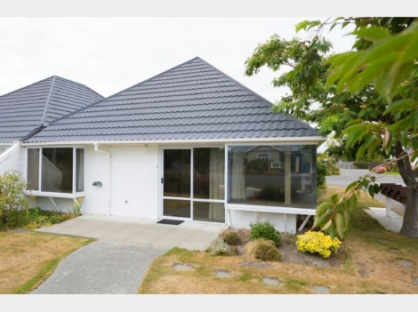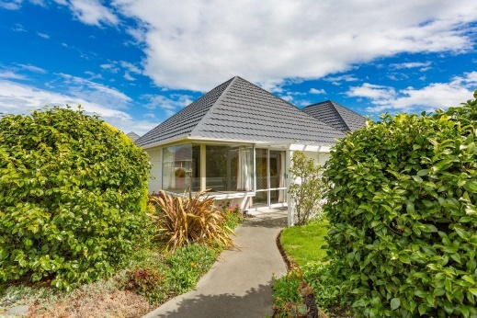‘Change of Lifestyle’

UNIT FOR SALE

30 High St., Leeston

Have you thought of down-sizing while you’re still active and have the energy to do something different?

ST. DAVID’S PLACE has a home waiting for you – to accomplish some of those ‘MUST DO’ adventures.

No lawn to mow, a small garden, friendly neighbours and warm, sunny home that is easy to keep.

We invite you to come and have a look and make an offer to purchase.

Contact: Noel Dalley 03 324 3171

Or John Lay 03 329 1617

**Our Mission Shed outreach**

**Donation to Christian Action — Mainland China Programme**

I am writing to express my gratitude for your generous donation of NZD$I,OOO in support of our Mainland China Programme. We give below brief updates of our Children's Homes, for your interest:

**Xining Children's Home**

Our first children's Home presently cares for 110 orphans and abandoned children (including 29 in foster care).

203 of our children have been adopted so far by loving families overseas to USA, Canada, Netherlands, Finland, Belgium, Sweden and Spain and we are hoping more will go soon, as "home" is the best place for a child; 30 childlren have been adopted in China.

**The Xining Children Rehabilitation Centre** which opened in October 2007 provides comprehensive services, including rehabilitation training and special education programmes, for our special needs children in the Home and in the community.

The 24 teenagers and young adults in Bridging Programme (6 in Xining children's Home and 18 in Xining Social Welfare Institute (XNSWI), will be entering their 2nd Phase of training in the Programme in the coming months. We will still continue to supervise their daily activities Learning at Xining Children's Home and monitoring their training in the sheltered workshop at XNSWI. Through this meaningful pilot project, the needs of these children are brought to another level of care and concern from all the parties involved. God's love for the children is so real and practical and thanks once again to your faithfulness in Him.

**Huangnan Children's Home**

Our second co-managed children's home which opened in 2008 presently cares for 477 orphans (including 6 in foster care). Most of these are Tibetan orphans and our goal is to provide an improved and independent life through homecare, education, health care, foster care, vocational training and counselling.

**Haixi Children's Home**

Our third Home, the Haixi Children's Home which opened in 201 1 now cares for 17 orphans and abandoned children.

**Guoluo Children's Home**

Our 4th children's home in Guoluo which opened in 2012 now cares for 55 orphans and abandoned children (including 5 in foster care).

**Hainan Children's Home**

Our 5th children's home which opened in 2013 now takes care of 51 orphans and abandoned children.

**Qinghai Education Grants**

We provide education grants to poor children, helping them to pursue higher studies and developing their potentials. These children are from poor families in Tongren County, and their parents are either farmers or herdsmen. So far, these grants have enabled Christian Action to provide financial assistance to 62 students to complete Tertiary Education in Huangnan Tibetan Autonomous Prefecture.

We are happy to share with you that the graduates were able to get jobs and acquired skills to be independent and are leading a better life, such as teaching Tibetan language and literature in a Boarding School, construction work in a Railway Company, veterinary medicine, computer network', social work, accountant in hospitals, the military, etc. These grants have helped to give them a direction in life and alleviate them from poverty and some of them are already contributing back to society.

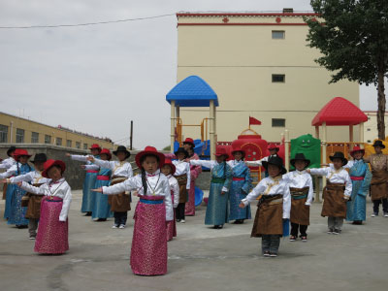As we continue Serving the Unserved for years to come, your kind contribution will help us to sustain our programmes that support the poor, disadvantaged, marginalised, displaced, and abandoned, aiming to give them hope, dignity and self-reliance. Christian Action currently operates 24 service points, many of which seek to serve underprivileged children from low-income communities, new arrivals, ethnic minorities, refugee families, as well as migrant domestic workers. In Qinghai, we have cared for nearly 1,400 orphans and currently co-manage five children's homes, and our first children's rehabilitation centre in the province.

Our service is based on the example of Jesus Christ who came to serve all people, regardless of their age, gender, nationality and religion.

**Cheung Ang Siew Mei, Executive Office, Christian Action.**

***A page for the children –***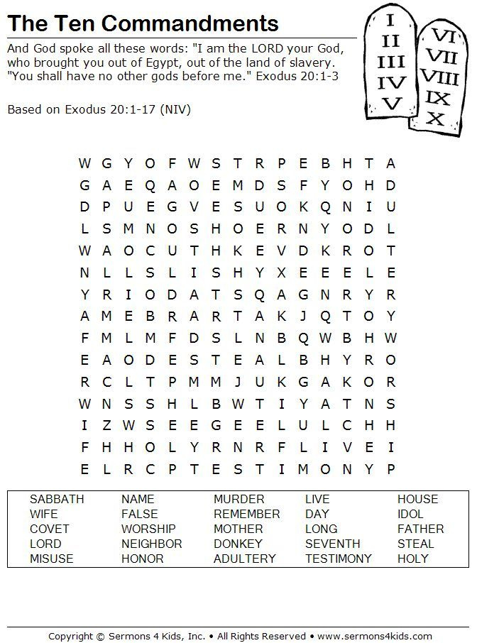

***Services & Events –***

***June 2018 to September 2018***

|  |  |  |
| --- | --- | --- |
| **June 2018** |  |  |
| Saturday 2 June |  | Life Touch Fellowship Camp |
| Sunday 3 June | 9.30am  11.00am  7.30pm | Communion Services – Pentecost 2  St. David’s, Leeston  Trinity, Dunsandel  Brookside (Anglican) Service |
| Tuesday 5June | 9.30am | Southbridge Home Group |
| Wednesday 6 June | 2pm | St. David’s Friendship group AGM |
| Thursday 7 June | 12 noon  7.00pm | Trinity ‘Lunch Bunch’  Men’s Fellowship – Leeston Library |
| Saturday 9 June | 7.30pm | Lifetouch Fellowship |
| Sunday 10 June | 9.30am  11.00am | Worship Services – Pentecost 3  St. David’s, Leeston  Trinity, Dunsandel |
| Thursday 14 June | 2 pm    7.30pm | St. David’s Fellowship AGM  Trinity Fellowship AGM  Dunsandel Sector meeting |
| Friday 15 June | 6 pm | ‘Fish and Chips’ tea and variety night |
| Saturday 16 June | 7.30pm | Lifetouch Fellowship |
| Sunday 17 June | 9.30am  11.00am  7.30pm | Worship Services – Pentecost 4  St. David’s, Leeston  Trinity, Dunsandel (Anglican)  Brookside (Communion Service) |
| Saturday 23 June | 7.30pm | Lifetouch Fellowship |
| Sunday 24 June | 9.30am  10.45am | Worship Services – Pentecost 5  St. David’s, Leeston  Café Church, Dunsandel |
| Thursday 28 June | 7.30pm | Parish Council at Leeston |
| Saturday 30 June | 7.30pm | Lifetouch Fellowship |

|  |  |  |
| --- | --- | --- |
| **July 2018** |  |  |
| Sunday 1 July  Sunday 1 July | 9.30am  11.00am  5.00pm  7.30pm | Communion Services – Pentecost 6  St. David’s, Leeston  Trinity, Dunsandel  Youth Pizza Café at St. David’s  Brookside (Anglican) |
| Tuesday 3 July | 9.30am | Southbridge Home Group |
| Wednesday 4 July | 2.00 pm | St. David’s Friendship group |
| Thursday 5 July | 12 noon  7.00pm | Trinity ‘Lunch Bunch’  Men’s Fellowship Group, Leeston Library |
| Saturday 7 July | 7.30pm | Lifetouch Fellowship |
| Sunday 8 July | 9.30 am  11.00 am | Worship Services – Pentecost 7  St. David’s, Leeston  Trinity, Dunsandel |
| Thursday 12 July | 2.00pm  7.30pm | St. David’s Fellowship group  Trinity Fellowship group  Leeston sector meeting |
| Saturday 14 July | 7.30pm | Lifetouch Fellowship |
| Sunday 15 July | 9.30 am  11.00am  7.30pm | Worship Services – Pentecost 8  St. David’s, Leeston  Trinity, Dunsandel (Anglican)  Brookside |
| Thursday 19 July | 7.30 pm | Dunsandel sector |
| Saturday 21 July | 7.30 pm | Lifetouch Fellowship |
| Sunday 22 July | 9.30am  10.45am | Worship Services – Pentecost 9  St. David’s, Leeston  Café Church, Trinity, Dunsandel |
| Thursday 26 July | 7.30pm | Parish Council meeting, Leeston |
| Saturday 28 July | 9.30am  7.30pm | Parish ‘Forum’, Leeston  Lifetouch Fellowship |
| Sunday 30 April | 9.30am | Combined Worship Service – Pentecost 10 at St. David’s, Leeston  CMM Presentation |

|  |  |  |
| --- | --- | --- |
| **August 2018** |  |  |
| Wednesday 1 Aug. | 2.00pm | St. David’s Friendship group |
| Thursday 2 August | 12 noon  7.00pm | Trinity ‘Lunch Bunch’  Men’s group, Leeston Library |
| Saturday 4 August | 7.30pm | Lifetouch Fellowship |
| Sunday 5 August | 9.30am  11.00am  5.00pm  7.30pm | Communion Services – Pentecost 11  St. David’s, Leeston  Trinity, Dunsandel  Youth Pizza Café at St. David’s  Brookside (Anglican) |
| Tuesday 7 August | 9.30 am | Southbridge home group |
| Thursday 9 August | 2.oopm  7.30pm | Fellowship groups  Leeston sector meeting |
| Saturday 11 August | 7.30pm | Lifetouch Fellowship |
| Sunday 12 August | 9.30am  11.00am | Worship Services – Pentecost 12  St. David’s, Leeston  Trinity, Dunsandel |
| Saturday 18 August | 7.30pm | Lifetouch Fellowship |
| Sunday 19 August | 9.30am  11.00am  7.00pm | Worship Services - Pentecost 13  St. David’s, Leeston  Trinity, Dunsandel (Anglican)  Brookside |
| Thursday 23 August | 7.30pm | Parish Council meeting at Leeston |
| Saturday 25 August | 7.30pm | Lifetouch Fellowship |
| Sunday 26 August | 9.30am  10.45am | Worship Services – Pentecost 14  St. David’s. Leeston  Café Church, Trinity, Dunsandel |

|  |  |  |
| --- | --- | --- |
| **September 2018** |  |  |
| Saturday 1 Sept. | 7.30 pm | Life Touch Fellowship |
| Sunday 2 Sept. (Father’s Day)  No Communion –  Rev. Heather away | 9.30am  11.00am  5.00pm  7.00pm | Worship Services – Pentecost 15  St. David’s, Leeston  Trinity, Dunsandel  Youth Pizza Café at St. David’s  Brookside (Anglican) |
| Tuesday 4 Sept. | 9.30am | Southbridge home group |
| Wednesday 5 Sept. | 2.00pm | St. David’s Friendship group |
| Thursday 6 Sept. | 7.00pm | Men’s group, Leeston Library |
| Saturday 8 Sept. | 7.30pm | Lifetouch Fellowship |
| Sunday 9 Sept. | 9.30am  11.00am | **Communion** Services – Pentecost 16  St. David’s, Leeston  Trinity, Dunsandel |
| Thursday 13 Sept. | 2.oopm  7.30pm | Fellowship groups  Leeston sector meeting |
| Saturday 15 Sept. | 7.30pm | Lifetouch Fellowship |
| Sunday 16 Sept. | 9.30am  11.00am  7.00pm | Worship Services  St. David’s, Leeston – Pentecost 17  Trinity, Dunsandel (Anglican)  Brookside |
| Thursday 20 Sept. | 7.30pm | Dunsandel sector meeting |
| Saturday 22 Sept. | 9.30am  7.30pm | Parish ‘Forum’ at Leeston  Lifetouch Fellowship |
| Sunday 23 Sept. | 9.30am  10.45am | Worship Services - Pentecost 18  St. David’s, Leeston  Café Church, Trinity, Dunsandel |
| Thursday 27 Sept. | 7.30pm | Parish Council meeting at Leeston |
| Saturday 29 Sept. | 7.30pm | Lifetouch Fellowship |
| Sunday 30 Sept. | 9.30am | Combined Parish Worship Service – Pentecost 19  At St. David’s, Leeston  Tear Fund presentation |

**Include in your prayers:**

Methodist Conference, September 28– October 3

Presbyterian Assembly, October 3 – 7

Both being held at St. Andrew’s College, Christchurch.

For all diary events please check for updates or alterations in the Weekly Bulletins as times and dates may change.

**Small Groups for all ages!**

|  |  |  |
| --- | --- | --- |
| **Groups for Adults** | |  |
| **Intercessory Prayer** | 7.00pm | Every Tuesday, Week 1; at St. James, Southbridge, Week 2, 54 Leeston and Lake Rd., Week 3; at St. David’s, last Tuesday of month at Trinity Church, Dunsandel.  *Contact John, ph: 021 170 3075* |
| **Southbridge Home Group** | 9.30am | 1st Tuesday of the month at Bev’s home in Southbridge. *Contact Janice, ph: 324 8202.* |
| **St. David’s Friendship**  **Group** | 2.00pm | 1st Wednesday of the month at various homes.  *Contact Hilary, ph: 324 3823.* |
| **St. David’s**  **Afternoon**  **Fellowship** | 2.00pm | 2nd Thursday of the month at the Church.  *Contact Janice, ph: 324 8202.* |
| **Trinity Women’s**  **Fellowship**  **Group** | 2.00pm | 2nd Thursday of the month at Trinity Church, Dunsandel.  *Contact Mavis ph: 325 4142.* |
| **Lunch Bunch** | 12.00 noon | A Dunsandel Trinity initiative –  1st Thursday of the month at various local eateries. *Contact Mavis ph: 325 4142.* |
| **Men’s Group** | 7.00pm | 1st Thursday of month at Community Room, Leeston Library. *Contact Gary*  *ph:* *324 3298 or 021 288 2091* |
| **Lifetouch Fellowship** | 7.30pm | Ministry for Filipino families and others.  Worship Service every Saturday. *Contact Teena, ph: 324 2240 or 021 081 62926.* |

|  |  |  |
| --- | --- | --- |
| **Groups for Children & Youth** | | |
| **Children’s**  **Ministry** |  | During worship each Sunday during the school term in Leeston.  *Contact Lois ph: 324 3884* |
| **Pre-school Music** | 9.45am –  10.30am | Wednesdays at St. David’s Church foyer, followed by coffee and chat for parents and caregivers in the church hall.  *Contact Naomi ph: 324 4075.* |
| **Youth Pizza Café** | 5.00pm –  7.00pm | 1st Sunday of the month at St. David’s Church, Leeston.  *Contact Linda ph: 324 2166* |

|  |
| --- |
| **Deadline for next newsletter - 17 September 2018**  **Contact person - Rev. Heather Kennedy**  Please send your information by email to [rev.heather.kennedy@gmail.com](mailto:rev.heather.kennedy@gmail.com) by the deadline date. |

|  |  |
| --- | --- |
| **CONTACT DETAILS** |  |
| **Minister** | **Phone** |
| Rev. Heather Kennedy | 324 3315 or 027 436 4554 |
| **Email** | rev.heather.kennedy@gmail.com |
| **Website** | [www.churchatellesmere.org.nz](http://www.churchatellesmere.org.nz/) |
| **Lifetouch Pastor** |  |
| Teena Dela Cruz | 324 2240 or 021 081 62926. |
| **Senior Laypersons** |  |
| Paul Birkett | 324 3884 |
| Robbie Stewart | 325 4535 |
| **Pastoral Care** |  |
| Lois & Paul | 324 3884 |
| Janice | 324 8202 |
| Robbie | 325 4535 |
| Noel | 329 1877 |